**Sub: Notice of 119th AGM- PHD Chamber of Commerce and Industry**

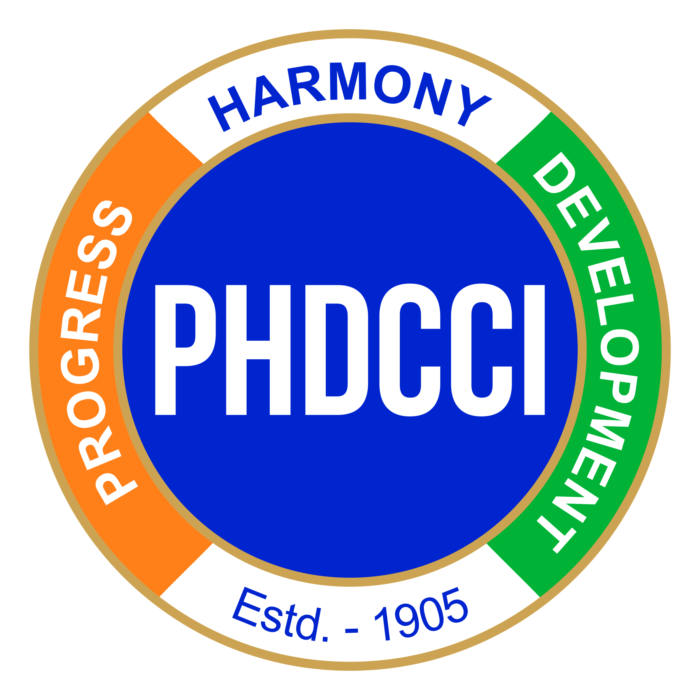

**PHD CHAMBER OF COMMERCE AND INDUSTRY**

PHD House, 4/2 Siri Institutional Area,

August Kranti Marg, New Delhi, 110016

CIN: U74899DL1951NPL001947

Website: [www.phdcci.in](http://www.phdcci.in) Email: [managingcomittee@phdcci.in](mailto:managingcomittee@phdcci.in)

Dear Members,

This is with reference to the 119th Annual General Meeting of PHD Chamber of Commerce and Industry (“the Chamber”) will be held on **Thursday, 10th October 2024 at 5:00 p.m. at Vigyan Bhawan, New Delhi through the hybrid mode (that is to say both physical and Video Conferencing (“VC”) / Other Audio Visual Means (“OAVM”).**

The Notice of AGM is being sent in electronic mode on Wednesday, September 18th, 2024 to all the members whose e-mail is registered with the Chamber. The Notice of the Annual General Meeting is also available on the website of the Chamber at [www.phdcci.in](http://www.phdcci.in) or [www.evotingindia.com](https://mailwizz2-04.m3c.in/latest/index.php/campaigns/cb848sy9z18fb/track-url/qw326qgkl1c4b/febf5dad683b21febeb4ee3f56102e4259e73c69).

Pursuant to Section 108 of the Companies Act, 2013 read with Rule 20 of the Companies (Management and Administration) Rules, 2014, your Company is pleased to provide to its members the facility to exercise their right to vote on resolutions proposed to be passed at the above said Annual General Meeting by electronic means before the AGM (remote e-voting) as well as during the AGM. The Company has engaged the services of Central Depository Services (India) Limited (CDSL) as the agency to provide e-voting facilities.

**The link to attend the AGM is as below-**

<https://zoom.us/j/94130887637?pwd=U1WadkLyb6CZQ3z0uMQF1MWRUuHJ9q.1>  
  
Meeting ID: 941 3088 7637  
Passcode: 146147

**The remote e-voting period shall begin on Saturday, October 05, 2024 at 09:00 A.M. and ends on Monday, October 07, 2024 at 05:00 P.M. Members may cast their votes accordingly. A person whose name is recorded in the Register of Members of the Chamber as on the cut-off date, i.e. Tuesday, October 01, 2024 only shall be entitled to avail the facility of remote e-voting.**

The remote e-voting shall not be allowed beyond the aforesaid date and time and the e-voting module shall be disabled by CDSL upon expiry of aforesaid period.

Members will be provided with the facility for voting through electronic voting system during the VC/OAVM proceedings at the AGM and those Members participating at the AGM, who have not already cast their vote by remote e-voting before the Meeting, will be eligible to exercise their right to vote during such proceedings of the AGM. Members who have cast their vote on resolution(s) by remote e-voting prior to the AGM will also be eligible to participate at the AGM through VC/OAVM but shall not be entitled to cast their vote on such resolution(s) again.

If any votes are cast by the members through the e-voting available during the AGM and if the same member has not participated in the AGM through VC/OAVM facility, then the votes cast by such member shall be considered invalid as the facility of e-voting during the AGM is available only to member attending the AGM.

**Detailed procedure for remote e-voting before the AGM / E-Voting during the AGM is provided in the Notes to the Notice of the AGM.**

If you have any queries or issues regarding e-voting system, you may refer the Frequently Asked Questions (“FAQs”) and e-voting manual available at [www.evotingindia.com](https://app1.cdslmails.com/gtrack?clientid=162960&ul=BQsPCQYDCwBNBUhAFlZDUQ9RQHRaVUUKC1dRCFdNBg4IREs=&ml=BQADRQFICwUGDUg=&sl=cUV0RWRnRGR8YUhRFEMAHgJUQ1hUUF8KERdWDlsfVQ==&pp=0&&c=0000), under help section or write an email to [helpdesk.evoting@cdslindia.com](mailto:helpdesk.evoting@cdslindia.com).

​

All grievances connected with the facility for voting by electronic means may be addressed to Mr. Rakesh Dalvi, Senior Manager, (CDSL) Central Depository Services (India) Limited, A Wing, 25th Floor, Marathon Futurex, Mafatlal Mill Compounds, N M Joshi Marg, Lower Parel (East), Mumbai – 400013 or contact on toll free no. 1800 21 09911.

Best Regards

**For PHD Chamber of Commerce and Industry**

**Sd/-**

**(Dr. Ranjeet Mehta)**

**CEO & Secretary General**

Place: New Delhi

Date: 18.09.2024